**VIDEO WORLD**

**GOVERNMENT POLYTECHNIC** **JAMNAGAR**

**COMPUTER ENGINEERING**

**PROJECT REPORT**

**FOR**

**DIPLOMA 6TH SEMESTER**

**VIDEO WORLD**

**A PROJECT REPORT**

**Submitted by**

JADAV BHAVYA (146350307028)

TRIVEDI PRIYANKA (146250307060)

DAVE UMA (146250307506)

**In fulfillment for the award of the degree**

**Of**

**Diploma ENGINEERING**

**In**

**Computer**



Government Polytechnic, Jamnagar

**Gujarat Technological University, Ahmadabad**

**Government Polytechnic, Jamnagar**

**Computer Engineering**

**2017**

**CERTIFICATE**

**Date:**

This is to certify that the dissertation entitled **“VIDEO WORLD”**  has been carried out by **JADAV BHAVYA, TRIVEDI PRIYANKA, DAVE UMA** under my guidance in fulfillment of the degree of Diploma Engineering in Computer (6th Semester) of Gujarat Technological University, Ahmadabad during the academic year 2016-17.

**Internal Guide Head of the Department**

D.N.KANJARIYA K.M.SHAH

**ACKNOWLEDGEMENT**

Every work that one complete successful stands on the constant encouragement, goodwill and support of the people around. I hereby, avail this opportunity to express my heartfelt gratitude to a number of people who extended their valuable time, and cooperation in developing this project.

We would like to thank this opportunity to express our deep gratitude and sincere thanks to my respected internal guide **D.N.KANJARIYA** and external guide provide us with the all valuable guidance, encouragement, support and constructive criticism without which this project would not have been materialized.

Last but not least we would like to thanks our parents and a family member whose love and support has allowed us to achieve this goal.

**With sincere regards**,

JADAV BHAVYA

TRIVEDI PRIYANKA

DAVE UMA

|  |  |  |
| --- | --- | --- |
| Sr. | TOPIC | Page No. |
| 1 | **1.0 Introduction**   * 1. Characteristic of system   2. Overview   3. Scope | 6 to 9 |
| 2 | **2.0 Software Requirement Specification**  2.1 User Characteristics  2.2 Functional Requirements | 10 to 20 |
| 3 | **3.0 System Analysis & Modeling**  3.1 Feasibility Study  3.2 Process Model  3.3 Used Based Modeling  3.3.1 Use-Case Diagrams | 21 to 26 |
| 4 | **4.0 System Analysis and Design**  4.1 Data Modeling  4.1.1 Data Dictionary  4.0.2 E-R Diagram  4.2 Behavioral Modeling  4.2.1 Data Flow Diagram | 27 to 45 |
| 5 | **5.0 System Design –UML**  5.1 Activity Diagrams | 46 to 48 |
| 6 | **6.0 Sample Coding/coding Standards** | 49 to 52 |
| 7 | **7.0 Testing**  7.1 Sample Test Cases | 53 to 58 |
| 8 | **8.0 System Interface Design**  8.1 Input-Output Forms Design | 59 to 66 |
| 9 | **9.0 Limitations and Future Enhancement**  9.1 Limitation  9.2 Future Enhancement | 67 to 68 |
| 10 | **10.0 Conclusion**  10.1 Advantages  10.2 Conclusion | 69 to 70 |
| 11 | **11.0 Bibliography**  11.1 Bibliography | 71 to 72 |
| 12 | **12.0 References**  12.1 References | 73 to 74 |

**INDEX**

CHAPTER NO: 1

INTRODUCTION

* 1. **CHARASTISTICS OF SYSTEM**
  2. **OVERVIEW**
  3. **SCOPE**

**1.1 CHARACTERISTICS**

* The **Video World** is use for user which enables the user upload video online user can register as a member if they want before they uploaded video.
* Video World site is user friendly .User can easily work with video world. User has to check availability of the video before they registered in the website.
* In our site user can see online videos and also uploaded vide and download videos.
* Also allow user to add the category of video and upload and download any type of video like Bollywood, cartoon, music, movie trailer, sports, news etc...
* In our site best functionality allow user can also see the history of videos which has been uploaded and downloaded and also add video watch later, but user cannot delete the video.

**1.2 OVERVIEW**

We are living in the current age of computer area. As everyone knows that today we are leaving in the world of technology & the computer technology is a subclass of this world. Everyone wants to integrate computer in his life at any sort. The software is the prime factor for achieving this goal & that’s why people move in this direction to make the things done by computer.

The project work assigned to **VIDEO WORLD** This system was already present there but was restricted as a web site only and there is no facility for any user that they can submit a dead link to the system.

The development of this system was started to develop a better system for better speed & accuracy and error tracking of link and better user interfaced system. We also keep in mind that system should be very user friendly. During system analysis proper care were taken about user requirements, because they were habitual of old system. So we noted all their requirements for proposed system & tried to make it really useful & user friendly.

**1.3 SCOPE**

* The **Video World** is an easy to use for user which enables the user upload video online user can register as a member if they want before they uploaded video.
* User has to check availability of the video before they registered in the website.
* In our site user can see online videos and also uploaded vide and download videos.
* Also allow user to add the category of video and upload and download any type of video like Bollywood, cartoon, music, movie trailer, sports, news etc...
* In our site best functionality allow user can also see the history of videos which has been uploaded and downloaded and also add video watch later, but user can not delete the video.

CHAPTER NO: 2

SOFTWARE REQUIRNMENT SPECIFICATION

**2.1 USER CHARASTIRISTICS**

**2.2 FUNCTIONAL REQUIRNMENTS**

**2.1 User Characteristics**:-

* Every user should be comfortable of working with computer and net browsing. He must have basic knowledge of English too.
* We have identified five potential classifications of users of our system:
* **Software Designers**: These are the most obvious users. They will use the system as a means of laying out the design of an as yet unimplemented system.
* **Software Developers**: These are the people that take the model generated by the designers and implement it in code. They may also use the system to identify the design of an existing system in order to maintain it.
* **Quality Engineers**: These users are usually responsible for ensuring that a design is feasible and/or reliable. They will therefore also need to be looking at the output from our system.
* **System Administrator:** Due to the client/server/concurrent nature of the system, someone needs to be responsible for security and maintenance of the system. This is the System Administrators role. The Administrator of the system, project or model need not be a member of the any of the other roles identified here.
* **The Client**: More often than not, software is designed for a client. The client may wish to see the design as lay out by the system and be able to see what exactly they are buying.
* **The General User:-**
* All users can be assumed to have the following characteristics:
* Ability to read and understand English.
* Familiarity with the operation of the basic Graphical User Interface (GUI) components of the Windows NT operating system.
* **The Software Designer:-**
* The Software Designer users can be assumed to have the following characteristics:
* A thorough knowledge of object oriented design notation.
* Familiarity with common design environments. For example, the concept of selecting a tool to draw with.
  1. **Software Requirement:**

Supported Operating Systems.

* Windows 8.1 (32-bit/64-bit), Windows 8 (32-bit/64-bit), Windows 7 (32bit/64-bit), Windows XP.

Supported Browsers.

* Microsoft Internet Explorer 8, 9, 10, 11
* Mozilla Firefox
* Google Chrome
  1. Hardware requirement:
* Processor used: Intel Pentium(MIN)
* Ram:256 MB(MIN)
* Admin:
  + Login
  + Add video
  + Delete video
  + Edit video
  + Manage User
  + Log out
* User:
  + Sign up
  + Log in
  + Log out
  + Search
* Authenticate User:
  + Sign up
  + Log in
  + Log out
  + Search
  + Like video
  + Dislike video
  + Give Comments
  + View history
  + Upload video
  + Download Video
  + Add Watch Later

Use case 1: Admin

R1. Login

* Description: Here the admin can login into his/her account.
* State: Here the user has been authenticated.
* Input: Admin username and password.
* Condition1:- Invalid Username or Password.
* Condition2:- Successfully Login.
* Output: Admin will successfully login or Invalid Details.
* Process: Here the admin will be validated against the system’s database.

R2: Add Video

* Description: Here the admin can add video.
* State: admin has selected ADD option.
* Input: Video detail.
* Output: Successfully added.
* Process: Changes made by admin will be saved permanently and stored in the database.

R3: Delete Video

* Description: Here the admin can delete video.
* State: admin has selected DELETE option.
* Input: select the video details.
* Output: Successfully deleted.
* Process: Changes made by admin will be saved permanently and stored in the database.

R4: Edit video

* Description: This functionality will allow admin to edit the details of their Posted video in the system.
* State: Admin must be log in.
* Input: Select the detail for video which he/she wants to add the details
* Output: Output will be updated details of video.
* Process: Upload and store the details updated by user

R4: Manage User

* Description: This functionality will allow admin to manage User.
* State: check authentication of all users.
* Input: Check User id and password.
* Output: Output will be result of authentication process.
* Process: manage all users and its content.

R6. Logout

* Description: Here the user can save their modifications in their profile and logout.
* State: supplier chooses logout option.
* Input: None.
* Output: Display website Homepage.
* Process: Here various processes will be done in the background from database.

User -2: User

R1. Sing up

* Description: The user will register to the website.
* State: User will choose the sign in option.
* Input: User will give his or her required details.
* Output: The result will be authenticated process.
* Process: The user details will be verified and according to the verification the decision will be display. i. e. User registered successfully or not.

R2. Login

* Description: The user will login to the site.
* State: User will choose the login option.
* Input: User will provide user id or password.
* Output: Access to system if sign in details are correct else error message.
* Process: User input will be authenticated with database record if user appears as a valid, user will be successfully sign in, and else error message will be displayed.

R3.search

* Description: This Functionality allow user to search video.
* State: user chooses the search option.
* Input: user input the name of video.
* Output: output will be display list of video.
* Process: Display the list of video.

R4. Logout:

* Description: Here the user can save their modifications in their profile and logout.
* State: User chooses logout option.
* Input: None.
* Output: Display website Homepage.
* Process: here various process will be done in the background from database.

User -3: Authenticate User

R1. Sing up

* Description: The user will register to the website.
* State: User will choose the sign in option.
* Input: User will give his or her required details.
* Output: The result will be authenticated process.
* Process: The user details will be verified and according to the verification the decision will be display. i. e. User registered successfully or not.

R2. Login

* Description: The user will login to the site.
* State: User will choose the login option.
* Input: User will provide user id or password.
* Output: Access to system if sign in details are correct else error message.
* Process: User input will be authenticated with database record if user appears as a valid, user will be successfully sign in, and else error message will be displayed.

R3.search

* Description: This Functionality allow user to search video.
* State: user chooses the search option.
* Input: user input the name of video.
* Output: output will be display list of video.
* Process: Display the list of video.

R4. Logout:

* Description: Here the user can save their modifications in their profile and logout.
* State: User choose logout option.
* Input: None.
* Output: Display website Homepage.
* Process: here various process will be done in the background from database.

R5. Like/Dislike video:

* Description: Here the user can like/Dislike the video.
* State: User must be log in.
* Input: User like/Dislike video.
* Output: Display total likes/Dislike.
* Process: here various process will be done in the background from database.

R6. Comment:

* Description: Here the user can Comment.
* State: User must be login.
* Input: Here the user send comment.
* Output: Display the comment.
* Process: Inquiry sanded by user will be displayed in website..

R7. Upload video:

* Description: This functionality will allow user to upload video in video world.
* State: User choose the upload.
* Input: Here user upload video.
* Output: video upload successfully.
* Process: video upload by user will be displayed in website.

R8. Download video:

* Description: This functionality will allow user to download video from video world.
* State: User select the download.
* Input: Here user download video.
* Output: video download successfully.
* Process: Downloading video.

R9. View History

* Description: This functionality will allow user to see the video history from video world.
* State: User must be login
* Input: Select video which he/she want to see video details.
* Output: Details of video.
* Process: User must be double click the view history.

R10.Add Watch Later:

* Description: This functionality will allow user to see the video which can be added into watch later.
* State: User selects the video.
* Input: Select video which he/she want to see video.
* Output: See the video.
* Process: User must be double click the view Video in watch later.
* **Non Functional Requirement.**
* Database availability.
* Software platform.
* 24 X 7 persistence web support.
* Respond to undesired events.

CHAPTER NO: 3

SYSTEM ANALYSIS AND MODELING

**3.1 FEASIBILITY STUDY**

**3.2 PROCESS MODEL**

**3.3 USER BASED MODELING**

3.3.1 USE-CASE DIAGRAMS

**3.1 Feasibility Study:**

Feasibility study is an important phase of SDLC. It is used to study that new system is feasible or not. Depending on the results of the preliminary investigation the survey is expanded to a more detailed feasibility study. Feasibility study is a test of a system proposal according to its workability, impact on the establishment, ability to meet user needs, and effective use of resources. The objective of feasibility study is not to solve the problem but to acquire a sense of its scope. During the study, the problem definition is crystallized and aspects of the problem to be included in the system are determined. Consequently, costs and benefits are estimated with greater accuracy at this stage.

Feasibility Study is the measure of how beneficial the development of a management system will be to an organization. Feasibility analysis is the process by which the feasibility is measured. Feasibility should be measured throughout the life cycle. The scope and the complexity of an apparently feasible project can change after the initial problems and opportunities are fully initialized or after the system has been designed. Thus, a project that is feasible at one point may become infeasible later. Let’s us study come checkpoints for our systems development life cycle.

There are different types of feasibility study analysis in the software development process of any project. These are:

* **Time Feasibility:**

Schedule feasibility is concerned with time. Time is greater resource for developing any system.

As we have mentioned earlier, we have enough time to complete and understanding the System and PHP We are two partners so we can divide the work evenly between us and it will provide more time to finish the work as the work load reduces. That means our System seems to be feasible with time.

Hence, the chance of insufficient experience and expertise halting the project development process was reduced. So, the risk of wasting huge amounts of time is eliminated. We also had resources to complete the goal in specified time period. So here the system is feasible for the schedule that we decided.

As we are in group of two people, we could able to finish our project in six months and that is enough time.

* **Cost Feasibility:**

Cost feasibility is important as it gives an idea if the project to be developed can be completed at a cost affordable both by the client and developer. All the tools such as PHP and MySQL were already available in the college and consultants, so they do not incur any cost.

The system is undertaken for the development as a part of the course curriculum. No development cost is to be charged for the project. Thus, the system is economical feasible for the developer. The required hardware and software are already available with the college and consultants.

Also, no manpower of the college needs to be active in the project so no extra cost of non-productive employee is incurred to the company. Thus, the project is economically feasible for the client also.

It also increases the speed of working. The college will be at profit if they implement this system because the cost of implementation is nominal as compared to the profit they will be earning in terms of efficiency by using this Application. Error handling is also done through this software, so no need for manpower. So, the project is economically feasible for the developer as well as the client.

**3.2 Process Model**

System Feasibility

**Waterfall Model**

Operations and Maintenance

Testing

Installation

Coding

Requirement Analysis

Integration

High level Design

**3.2 User-Based Modeling:**

**3.2.1 Use-Case Diagrams:**

**ADMIN:**

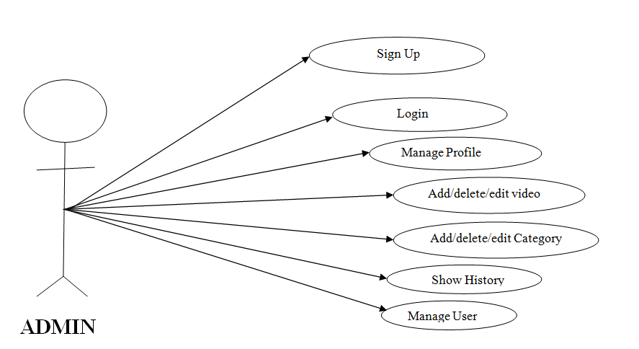

**USER:**

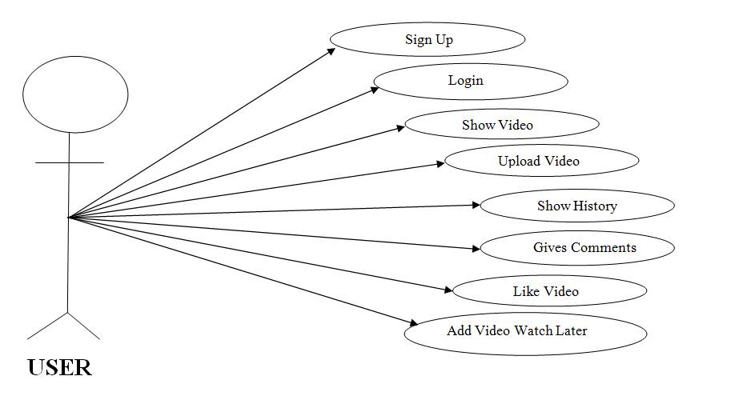

CHAPTER NO: 4

SYSTEM ANALYSIS AND DESIGN

**4.0 DATA MODELING**

4.1 .1 Data Dictionary

4.1.2 E-R Diagram

**4.2 BEHEVIROAL MODELING**

**4.2.1 Data Flow Diagram**

4.2.1.1Context Level Diagram

4.2.1.2 DFD-Level1

4.2.1.2 DFD-Level2

**4.1 DATA MODELING:**

**4.1.1 Data Dictionary**

**ADMIN:**

Table 1: admin_info

|  |  |  |  |
| --- | --- | --- | --- |
| No. | Field Name | Data type | Description |
| 1 | Email | Varchar | It is the email id of admin |
| 2 | Password | int | It refers to the password of admin |

Table 2: User_info

|  |  |  |  |
| --- | --- | --- | --- |
| No. | Field Name | Data type | Description |
| 1 | U_id | Int(5) | It refers to the identification number of user |
| 2 | Name | Varchar2 | It refers to the name of user |
| 3 | Email | Varchar2 | It refers to the email address |
| 4 | Password | Int(10) | It refers to the password of user |
| 5 | Contact | Int(10) | It refers to the contact of user |

**USER:**

Table 3: Category

|  |  |  |  |
| --- | --- | --- | --- |
| No. | Field Name | Data type | Description |
| 1 | Cid | Int(3) | It is the identification number of category |
| 2 | Name | Varchar2 | It refers to the name of category |
| 3 | Image | Varchar2 | It refers to the image |
| 4 | Icon | Varchar2 | It refers to the icon |

Table 4: History

|  |  |  |  |
| --- | --- | --- | --- |
| No. | Field Name | Data type | Description |
| 1 | H_id | Int(3) | It is the identification number of history |
| 2 | U_id | Int(3) | It is the identification number of user |
| 3 | V_id | Int(3) | It is the identification number of video |

Table 5: Video

|  |  |  |  |
| --- | --- | --- | --- |
| No. | Field Name | Data type | Description |
| 1 | V_id | Int | It is the identification number of video |
| 2 | V_name | Varchar2 | It refers to the name of video |
| 3 | Description | Varchar2 | It is the description of video |
| 4 | Video | Varchar2 | It is refers the video |
| 5 | Vsize | Varchar2 | It is refers the size of video |
| 6 | Vtype | Varchar2 | It refers the type of video |
| 7 | Cid | Int | It is refers the identification number of category |
| 8 | Image | Int | It is refers the image. |

Table 6: Watch later

|  |  |  |  |
| --- | --- | --- | --- |
| No. | Field Name | Data type | Description |
| 1 | W_id | Int(3) | It is the identification number of watch_later. |
| 2 | U_id | Int(3) | It is the identification number of user |
| 3 | V_id | Int(3) | It is the identification number of video |

Table 7: Comment

|  |  |  |  |
| --- | --- | --- | --- |
| No. | Field Name | Data type | Description |
| 1 | Email | Varchar | It is the email id of admin. |
| 2 | Description | Varchar | It stores the description of comments. |

Table 7: Like

|  |  |  |  |
| --- | --- | --- | --- |
| No. | Field Name | Data type | Description |
| 1 | Like_id | Int(3) | It is the identification number of likes. |
| 2 | V_id | Int(3) | It is the identification number of video |
| 3 | Status | Varchar2 | It refers the status of likes. |
| 4 | U_id | Int(3) | It is the identification number of User. |

Table 8: User_video

|  |  |  |  |
| --- | --- | --- | --- |
| No. | Field Name | Data type | Description |
| 1 | V_id | Int(3) | It is the identification number of video |
| 2 | U_id | Int(3) | It is the identification number of user |

**4.1.2 E-R Diagram**

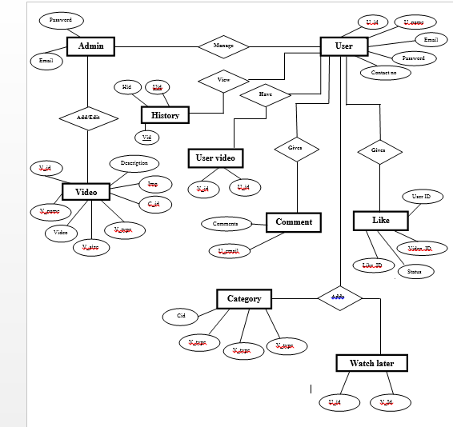

**4.2 BEHEVIROAL MODELING**

**4.2.1 Data Flow Diagram**

**For Admin**

**Level 0**

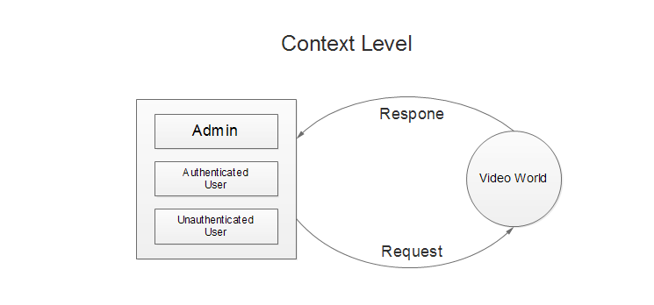

**Level 1**

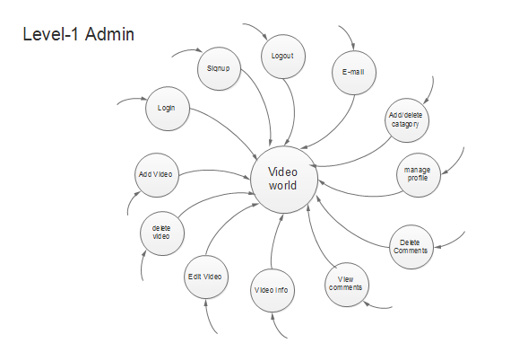

**Level 2**

1.1 login

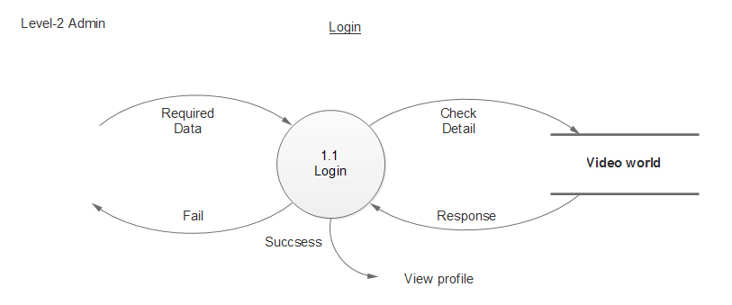

1.2

1.2 Manage Profile:

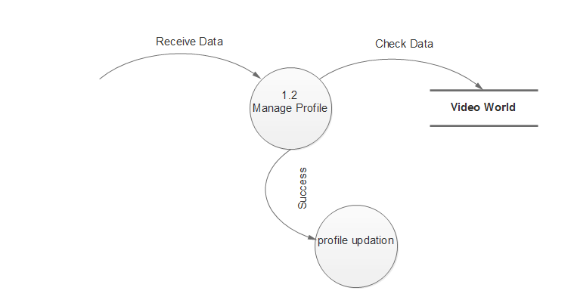

1.3 Manage Profile:

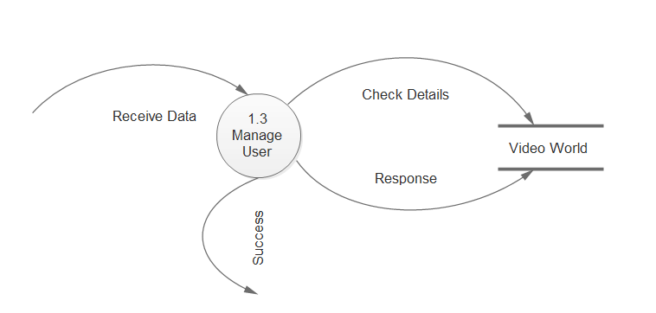

* 1. View Comments

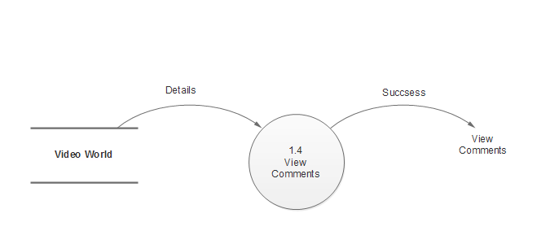

1.5 Delete Profile

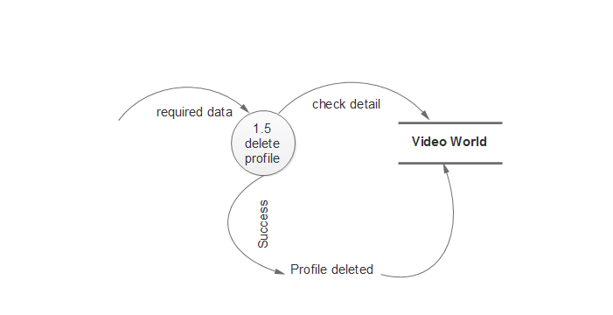

1.6 Add Video

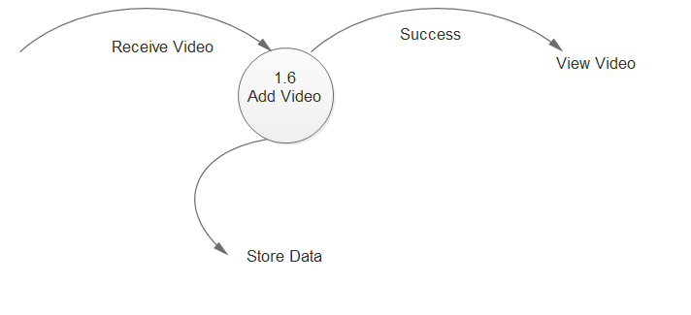

1.7 Delete Video

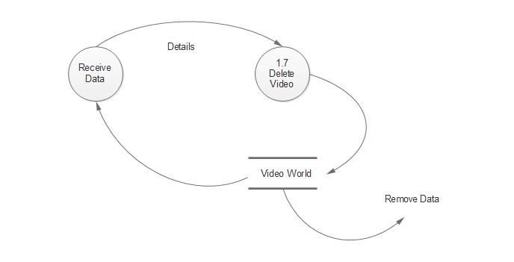

1.8 Edit Video

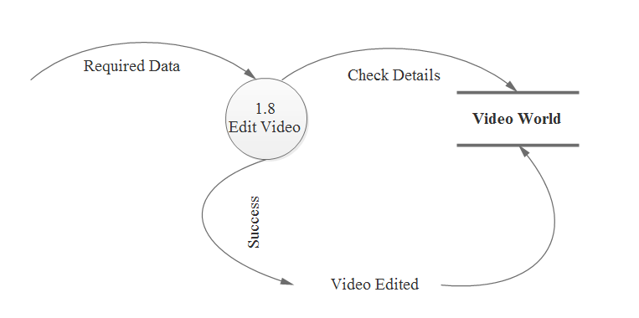

1.9 Show History

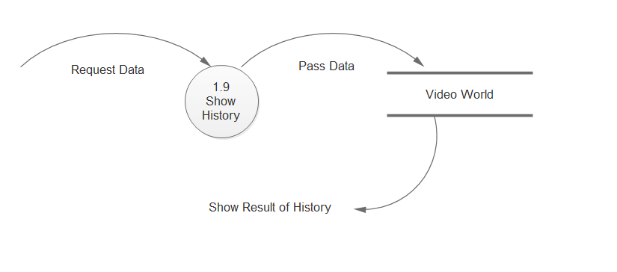

1.10 Add Category

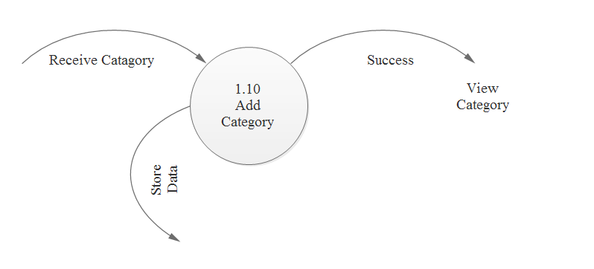

1.11Delete Category

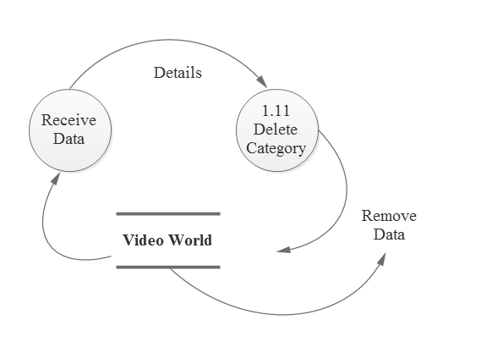

**For User:**

**Level 1**

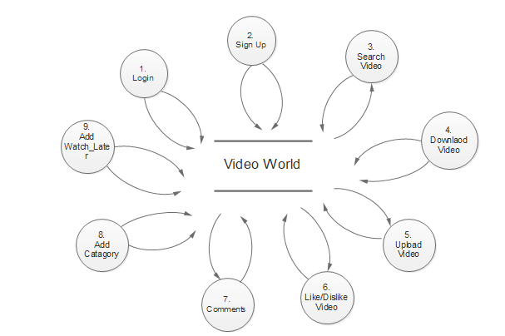

**Level-2**

2.1 Sign Up

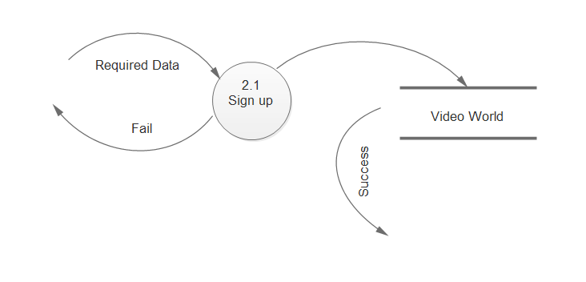

2.2 Login

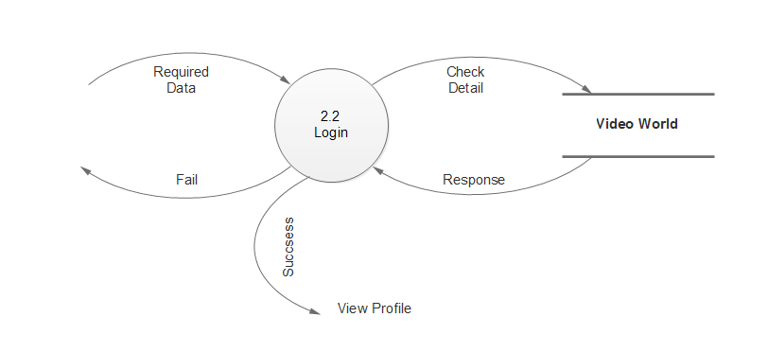

* 1. Search Video

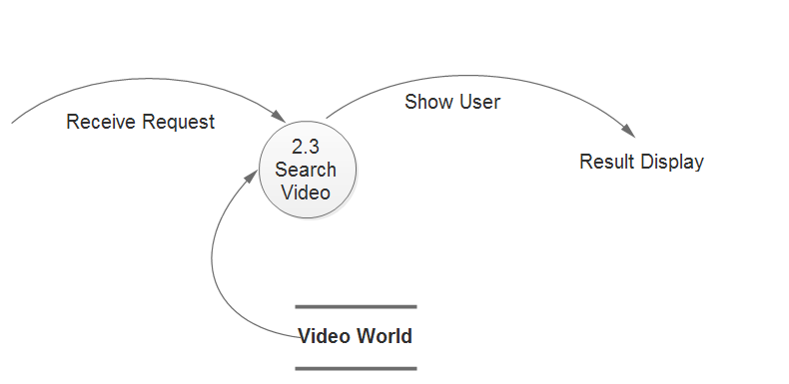

2.4 Download Video

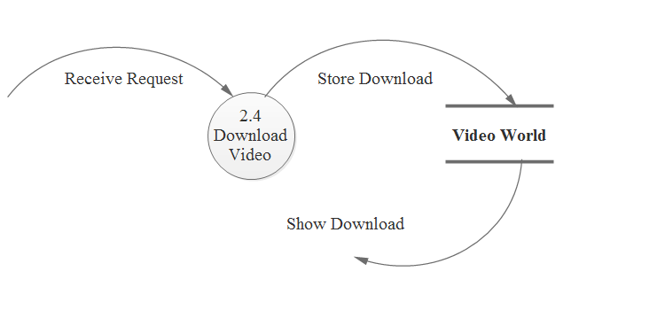

2.5 Upload Video

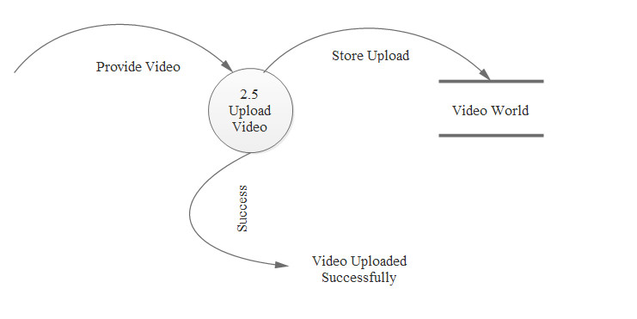

2.6 Like/Dislike Video

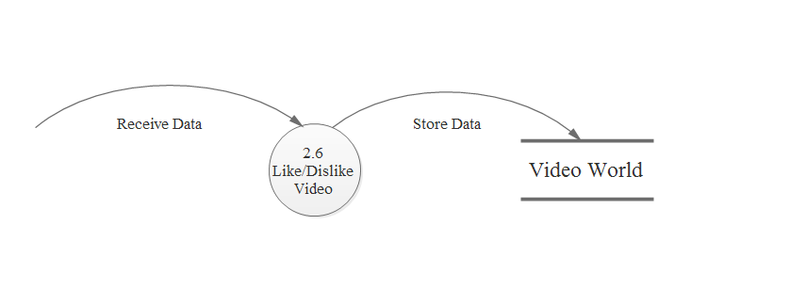

2.7 Add Category

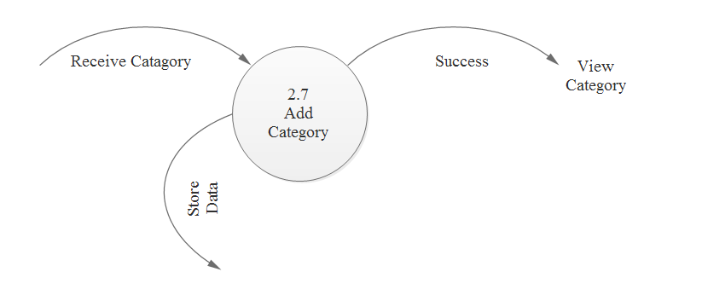

2.8 Add Watch Later

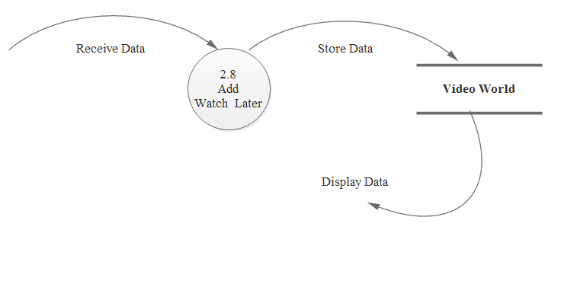

2.9 View History

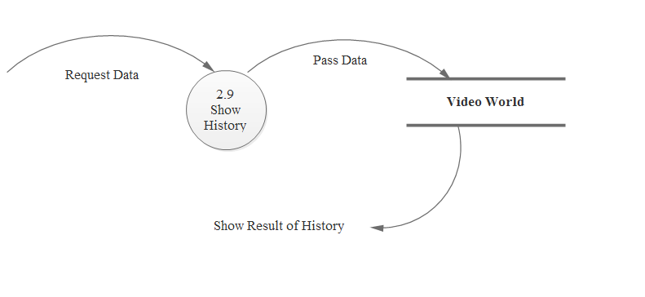

2.10 Give Comments

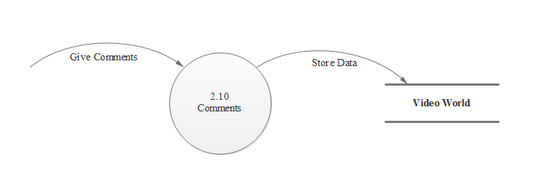

**For Unauthenticated User**

**Level 1**

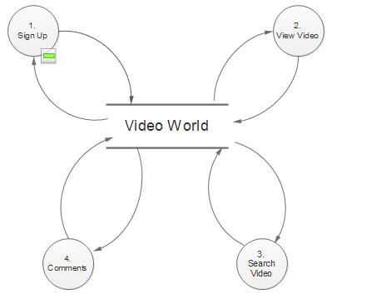

**Level 2**

3.1 Sign Up

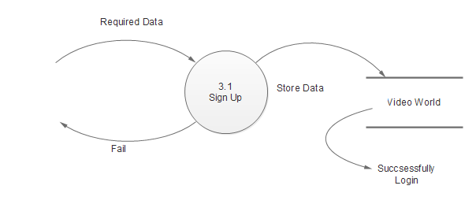

3.2 Search Video

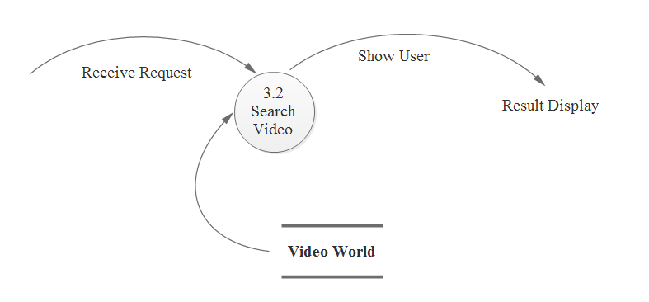

3.3 View Video

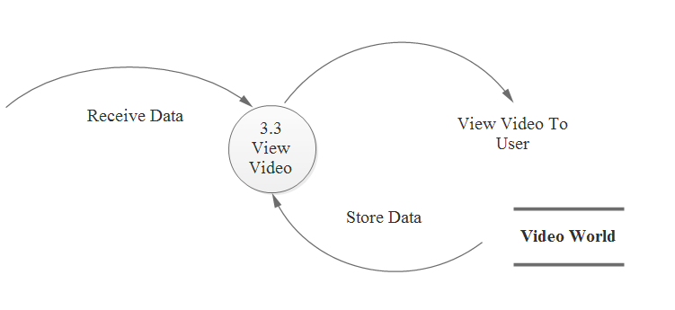

3.4 View Comments

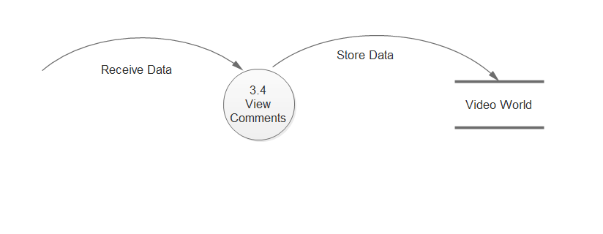

CHAPTER NO: 5

SYSTEM DESIGN-UML

**5.1 Activity Diagram**

**5.1 Activity Diagram**

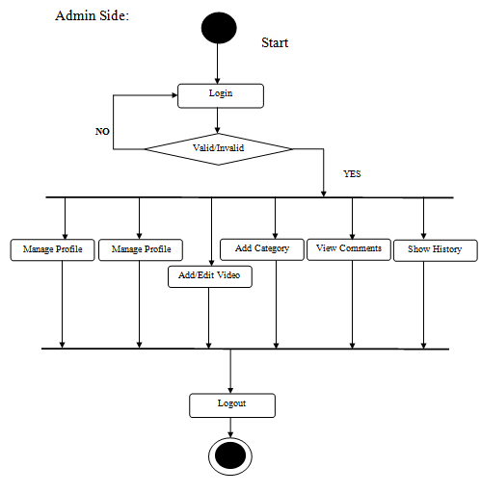

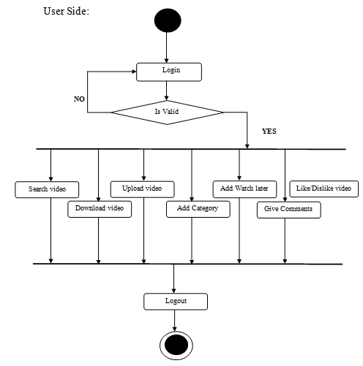

CHAPTER NO: 6

SAMPLE CODING

**6.0 Coding Standards**

**6.0 Coding Standards**

**1 Search.php**

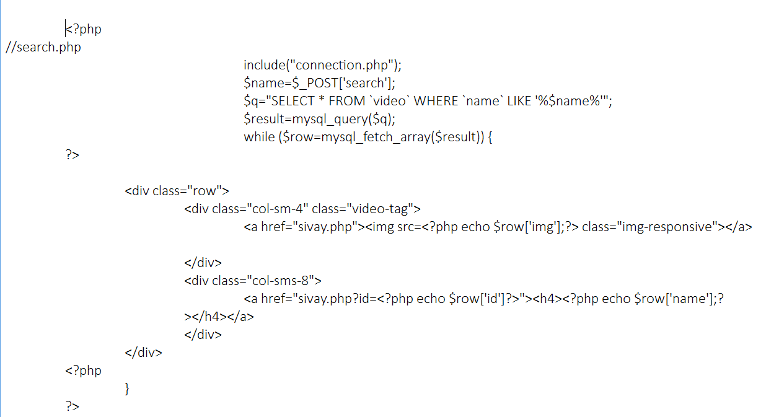

**2. Upload Video.php**

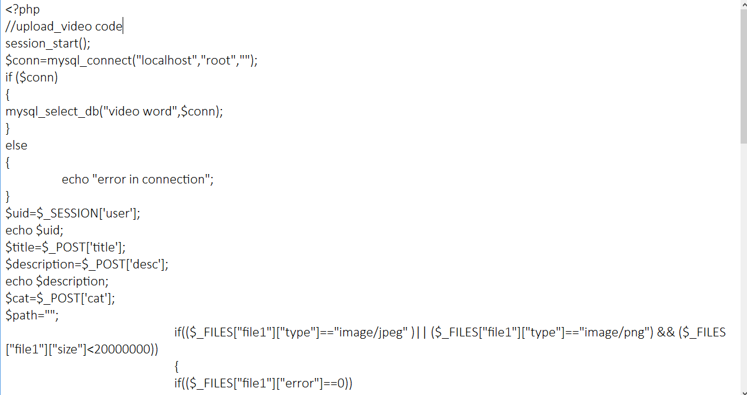

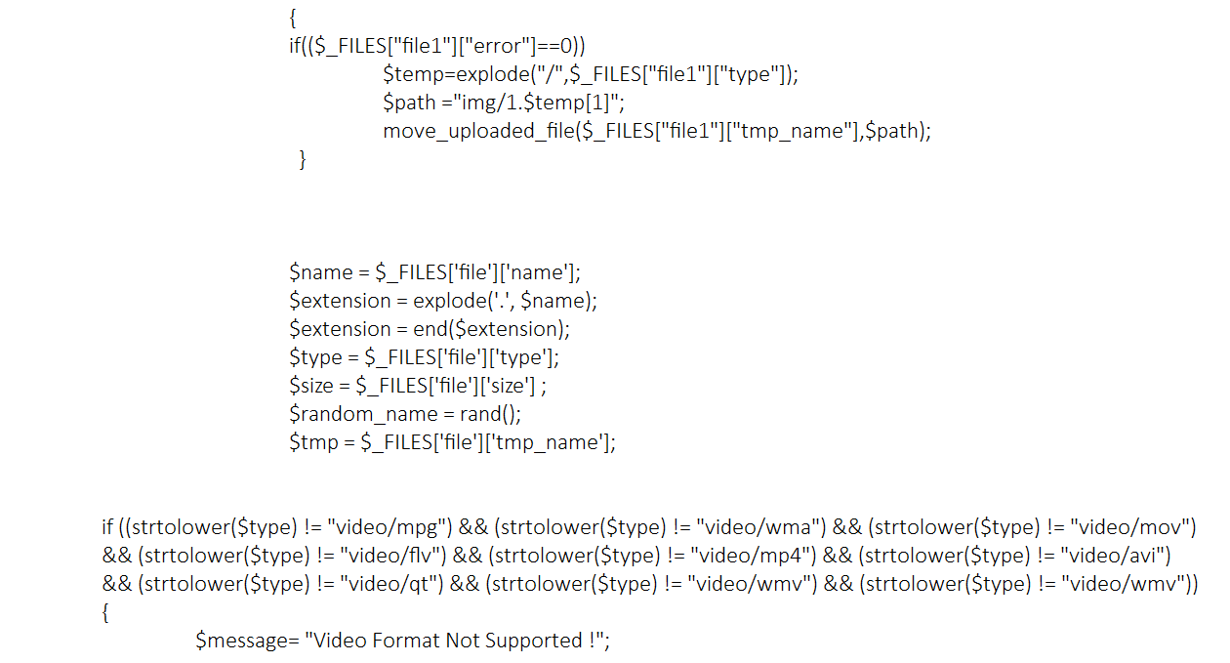

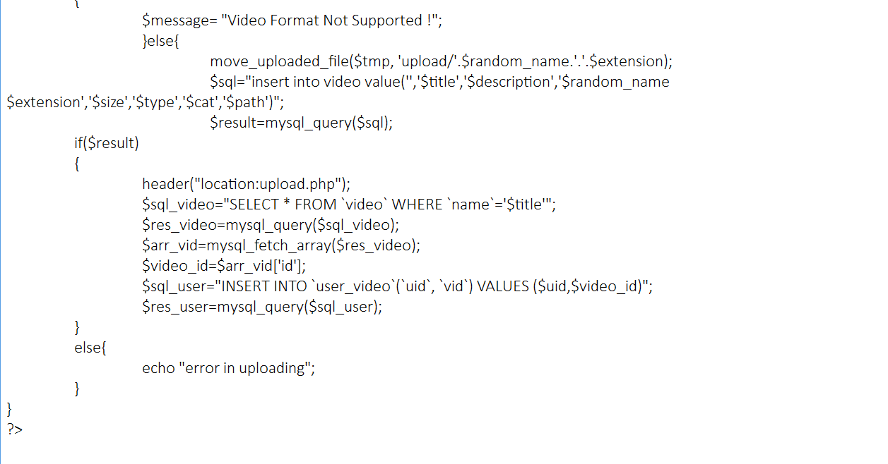

**3.Add to watch later.php**

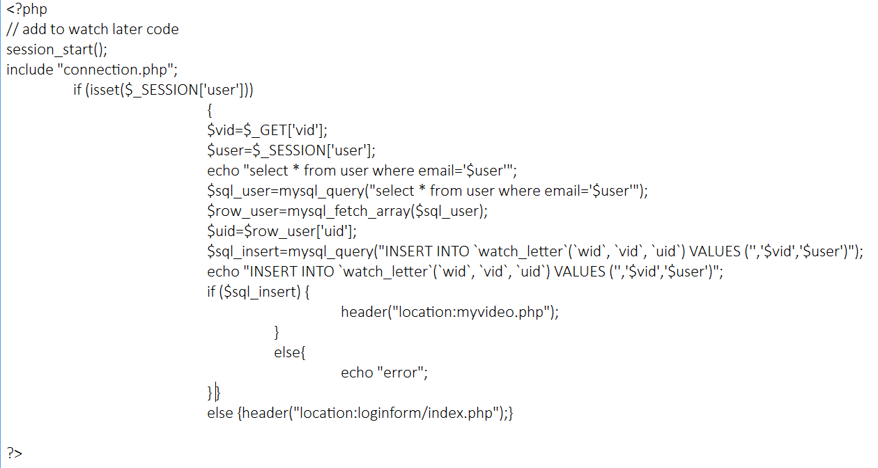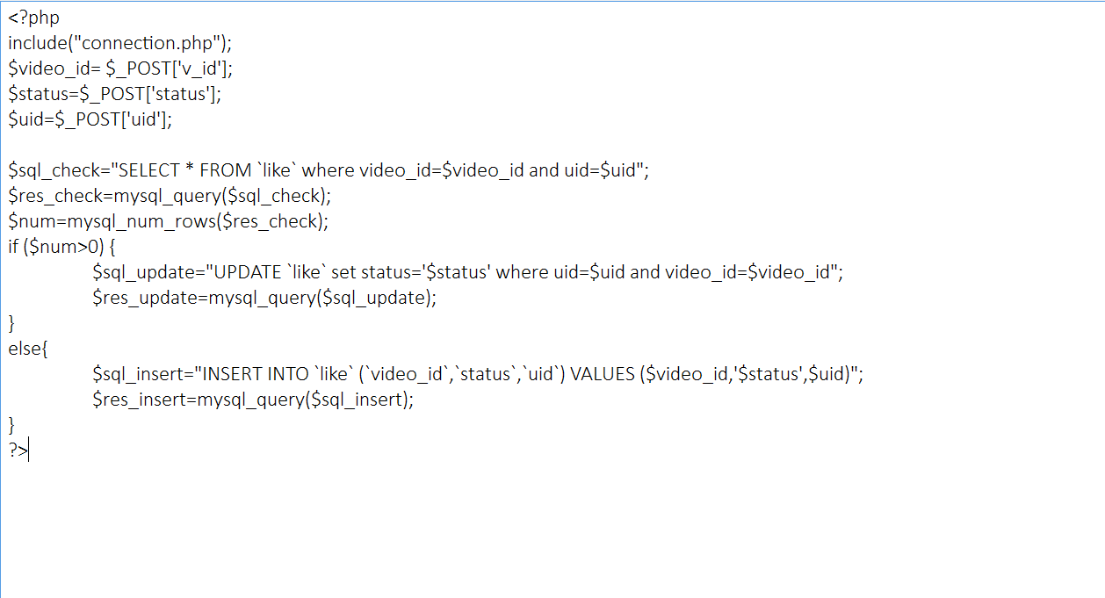

**4. like and unlike Video.php**

CHAPTER NO: 7

TESTING

**7.1 Sample Test Cases**

**7.1 Sample Test cases**

|  |  |
| --- | --- |
| Test Case:1(Admin) | |
| Test to be performed | Login of admin |
| Expected Result | Successfully logged-in |
| Actual Result | Successfully Logged in |
| Result | PASS |
| Type of Test | Module Test |

|  |  |
| --- | --- |
| Test Case:2(Admin) | |
| Test to be performed | To verify that when admin will click on Block, user should be blocked, effect should be reflected in database as well as on the screen |
| Expected Result | User should be blocked in to database and should not be able to login in to the website. |
| Actual Result | User is blocked from database and also not be able to login to the system. |
| Result | PASS |
| Type of Test | Module Test |

|  |  |
| --- | --- |
| Test Case:3(Admin) | |
| Test to be performed | To verify that when admin will click on add category button to add new category for discussion should be reflected on database as well as on the screen |
| Expected Result | Category should be added, it should be added on the screen. |
| Actual Result | New category is added into the database as well as on the screen. |
| Result | PASS |
| Type of Test | Module Test |

|  |  |
| --- | --- |
| Test Case:4(Admin) | |
| Test to be performed | Details of profile edit something new in profile |
| Expected Result | Profile should be added, it should be added on the screen. |
| Actual Result | Edited profile will be displayed. |
| Result | PASS |
| Type of Test | Module Test |

|  |  |
| --- | --- |
| Test Case:5(Admin) | |
| Test to be performed | To verify that when admin will click on “View  Comment” buttons all the comment should be displayed on the screen. |
| Expected Result | Comments should be displayed on screen. |
| Actual Result | Comments should be displayed on screen |
| Result | PASS |
| Type of Test | Module Test |

|  |  |
| --- | --- |
| Test Case:6(User) | |
| Test to be performed | The login system must work properly and user email and password must be checked from database. |
| Expected Result | While checking specific error message should be displayed to user if the result does not match. |
| Actual Result | User will be provided with specific error message. |
| Result | PASS |
| Type of Test | Module Test |

|  |  |
| --- | --- |
| Test Case:7(User) | |
| Test to be performed | Validation of every input on the registration page. |
| Expected Result | Do not register if input type does not match. |
| Actual Result | Can’t register if user has filled wrong input data. |
| Result | PASS |
| Type of Test | Module Test |

|  |  |
| --- | --- |
| Test Case:8(User) | |
| Test to be performed | To verify that when user will search for video in search box related video should be displayed. |
| Expected Result | Related video should be display in the search box. |
| Actual Result | Related video will be display. |
| Result | PASS |
| Type of Test | Module Test |

|  |  |
| --- | --- |
| Test Case:9(User) | |
| Test to be performed | To verify that when user will click on add category button to add new category for discussion should be reflected on database as well as on the screen |
| Expected Result | Category should be added, it should be added on the screen. |
| Actual Result | New category is added into the database as well as on the screen. |
| Result | PASS |
| Type of Test | Module Test |

|  |  |
| --- | --- |
| Test Case:10(User) | |
| Test to be performed | When User upload video. User should be knows the details of video, path is inserted in database. User can click “Upload” button particular video should be uploaded on screen. |
| Expected Result | Video will be added to Database and user profile. |
| Actual Result | Video is successfully uploaded. |
| Result | PASS |
| Type of Test | Module test. |

|  |  |
| --- | --- |
| Test Case:11(User) | |
| Test to be performed | User download video user can click “download” button particular video download should be appearing on screen. |
| Expected Result | Downloaded Video should appear on the screen. |
| Actual Result | Downloaded video will be appear on the screen. |
| Result | PASS |
| Type of Test | Module test. |

|  |  |
| --- | --- |
| Test Case:12(User) | |
| Test to be performed | To verify that when user will Comment in the Comment box and click to send button the particular Comments should be display on the screen. |
| Expected Result | The comment should be added to the database. |
| Actual Result | The comment will be added to the database. |
| Result | PASS |
| Type of Test | Module Test |

|  |  |
| --- | --- |
| Test Case:13(User) | |
| Test to be performed | To verify when user click Add “watch later” button, particular video should be added in watch later and database. |
| Expected Result | Video should be added to the Database. |
| Actual Result | Video should be added to the Database. |
| Result | PASS |
| Type of Test | Module Test |

|  |  |
| --- | --- |
| Test Case:14(User) | |
| Test to be performed | To verify when user click Add “like/dislike” button, particular video should be like/dislike added in database. |
| Expected Result | Liked/unliked Video should be added to the Database. |
| Actual Result | Liked/unliked Video should be added to the Database. |
| Result | PASS |
| Type of Test | Module Test |

|  |  |
| --- | --- |
| Test Case:15(User) | |
| Test to be performed | To verify that when user will click on log- out button user must be sign out and session must be destroyed. |
| Expected Result | User should be signed-out and session must be destroyed. |
| Actual Result | User is signed-out and only can enter in to the system after log-in. |
| Result | PASS |
| Type of Test | Module Test |

CHAPTER NO: 8

SYSTEM INTERFACE DESIGN

**8.1 Input-Output Forms Design**

**Fig1:**Admin Login Page

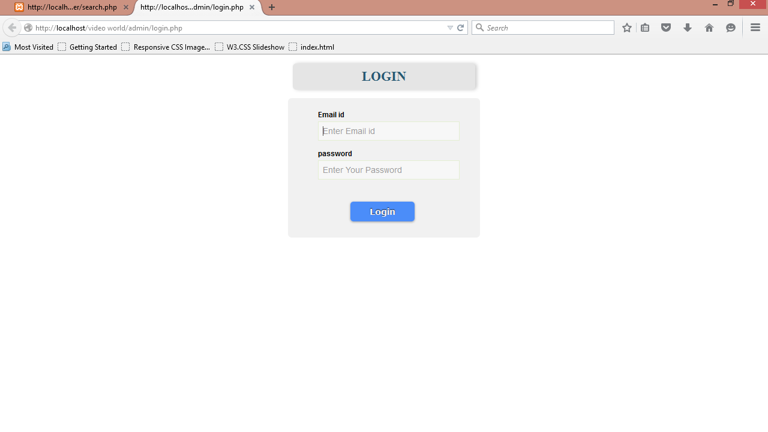

**Fig2:**Admin Upload Video Page.

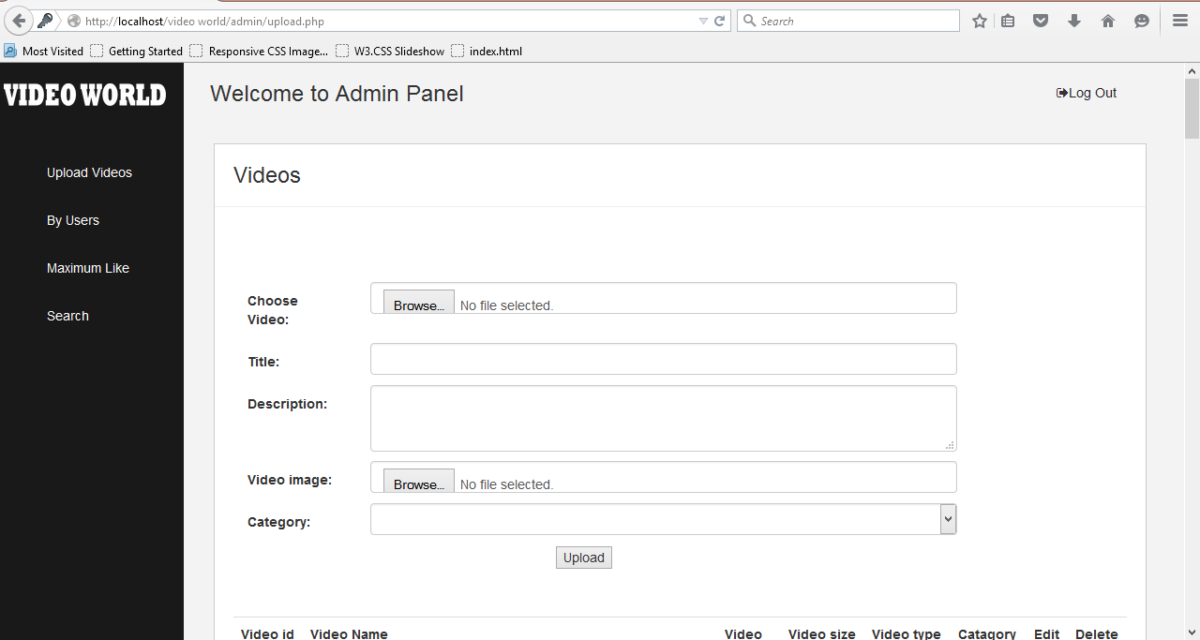

**Fig3:** Admin Uploaded Videos Page.

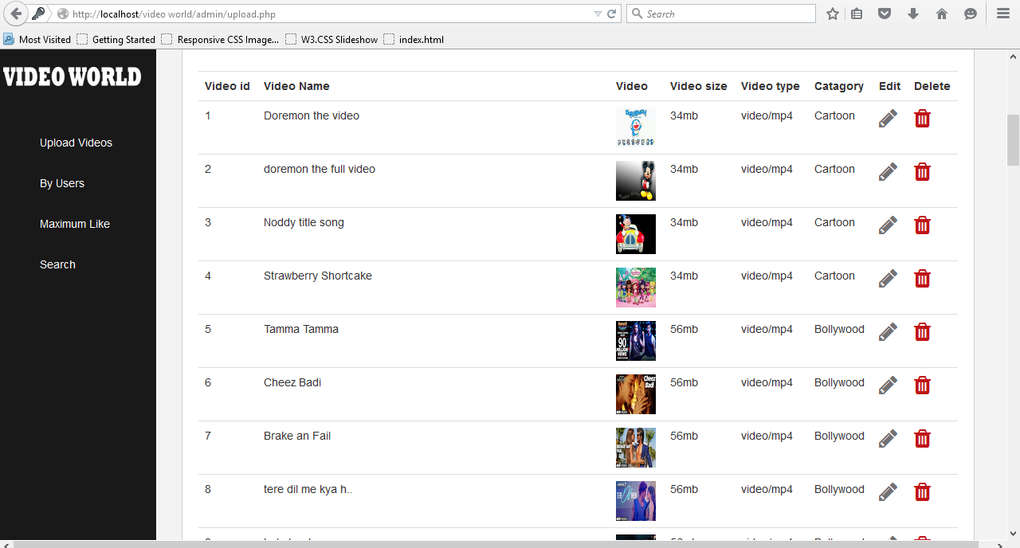

**Fig4:** Admin By Users Uploaded Video Page.

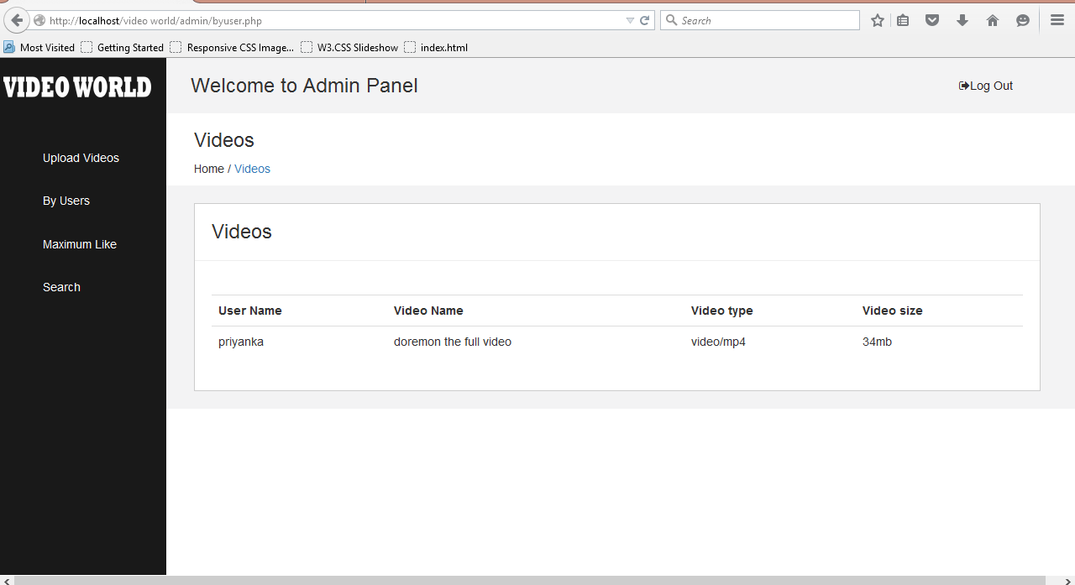

**Fig5:** Admin Maximum Video Like Page.

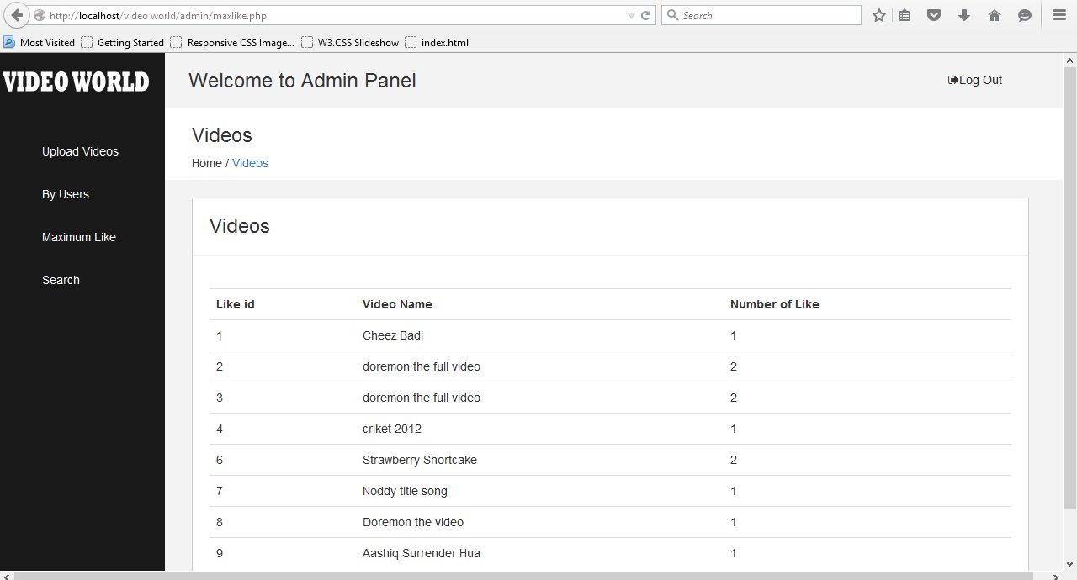

**Fig6:** Admin Search Video Page.

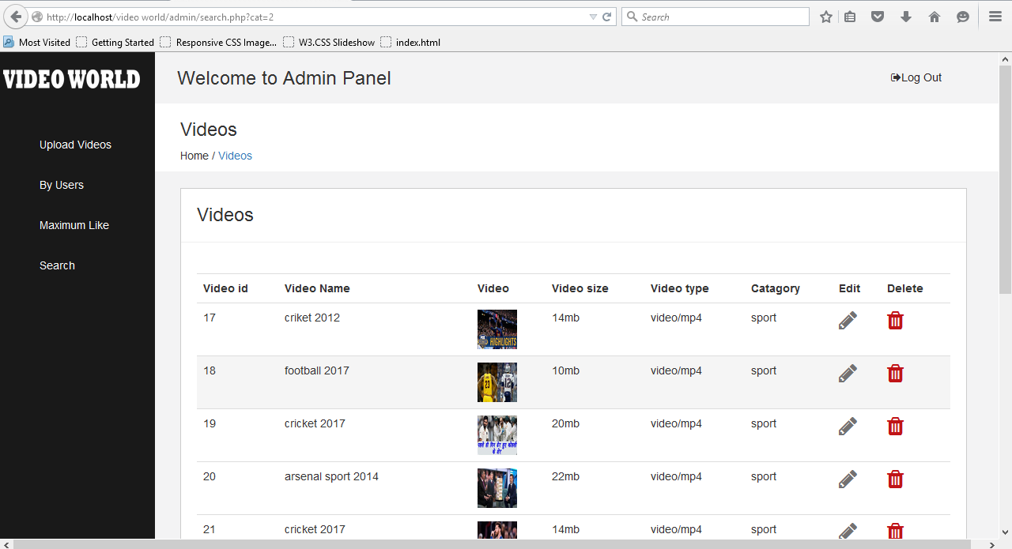

**Fig7:**User Login Page.

**Fig8:**User Sign Up Page.

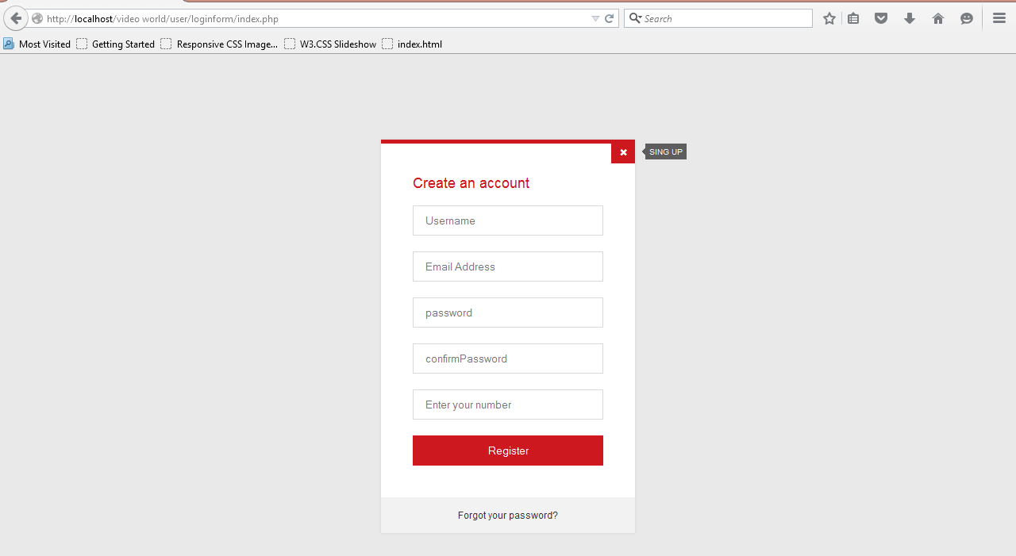

**Fig9:**User Home Page.

**Fig 9:**User Home Page.

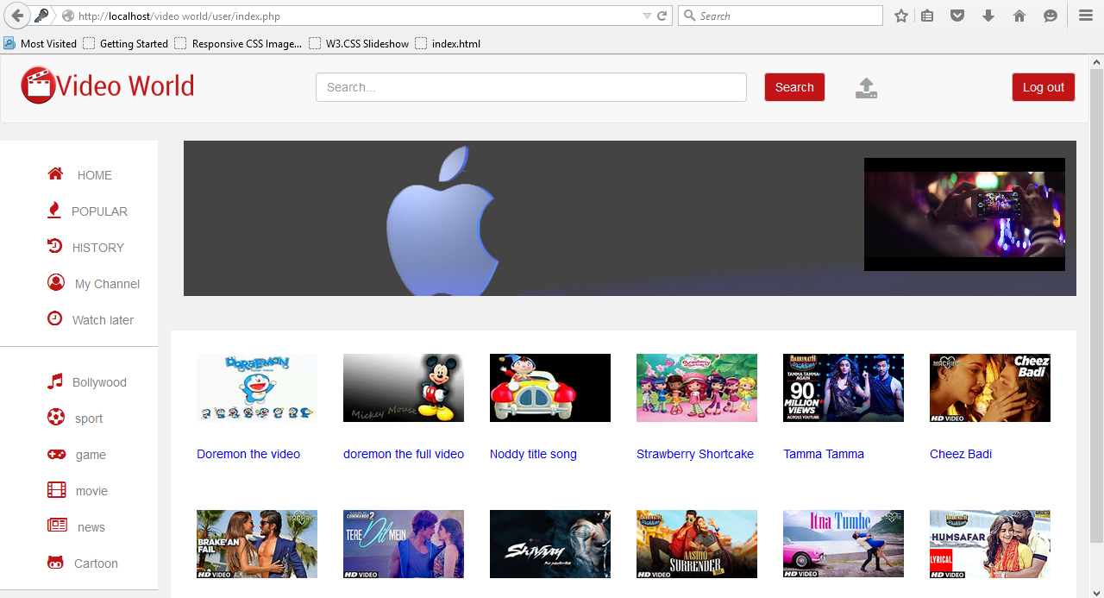

**Fig10:**User Popular Video Page.

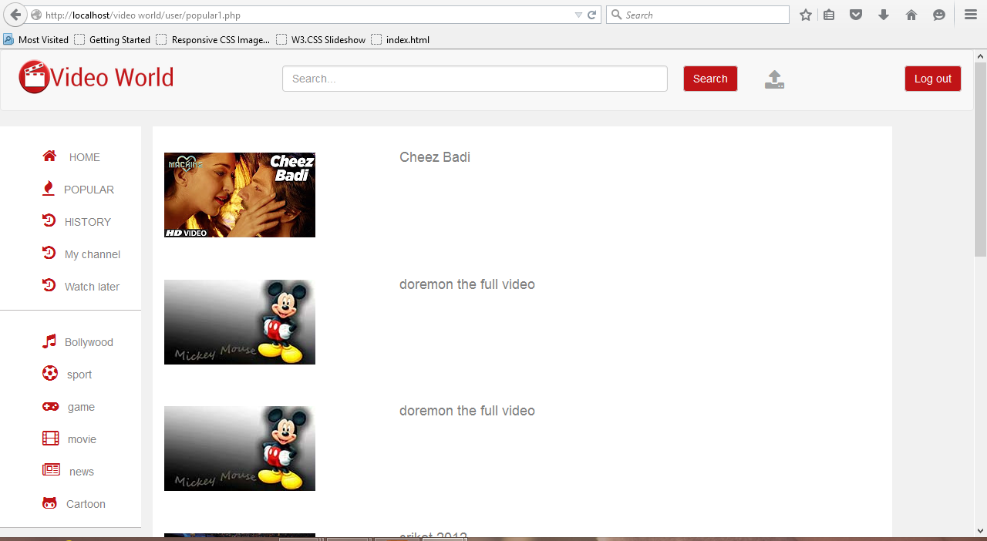

**Fig11:**User History of Video Page.

**Fig11:**User Popular Video Page.

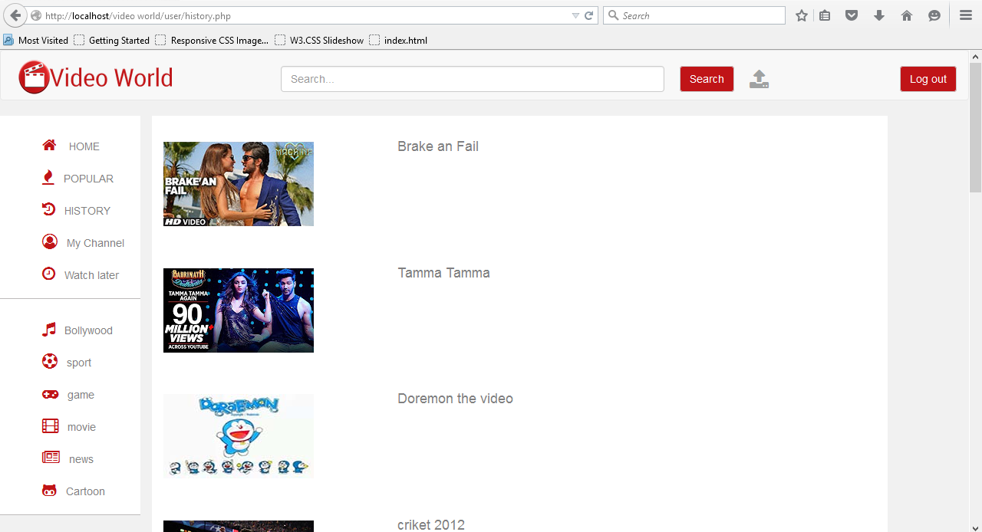

**Fig12:**User My Channel Video Page.

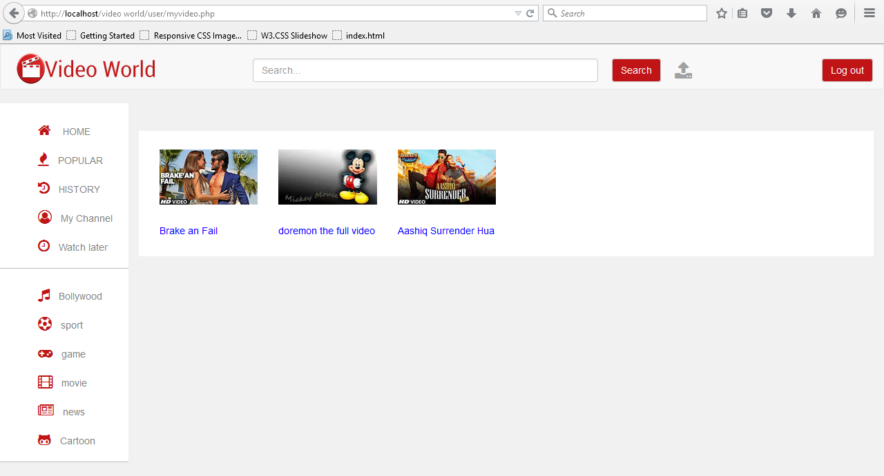

**Fig13:**User Search Video Page.

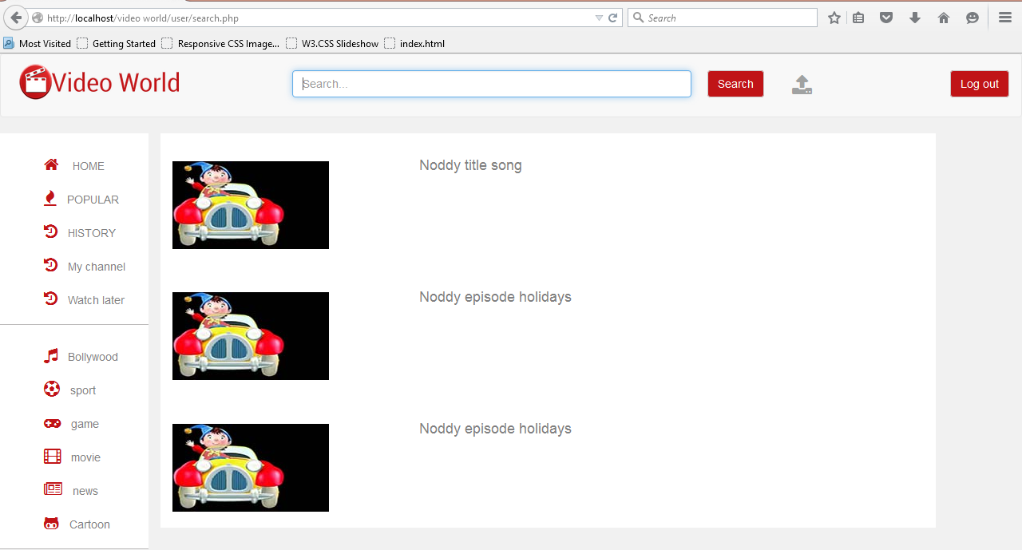

**Fig14:**User Category Page.

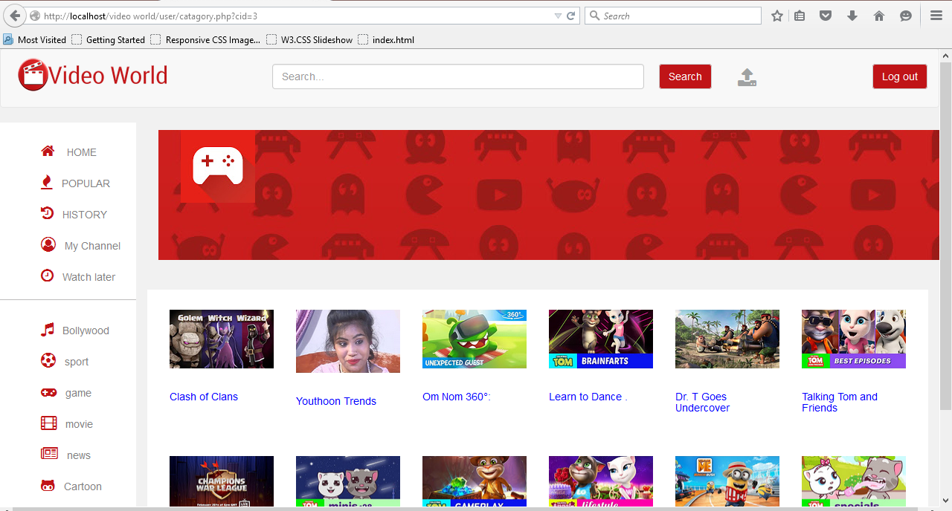

CHAPTER NO: 9

LIMITATIONS AND FUTURE ENHANCEMENT

**9.1 Limitations**

**9.2 Future Enhancement**

**9.1 Limitation**

* End user is not allowed to give categories.
* User registration allowed only with Email id.
* Videos cannot be uploaded as reference for discussion.

**9.2 Future Enhancement**

* Registered user will be able to add categories with the admin’s approval .
* Discussion will be made through video calling.
* Reference material for discussion will be enhanced by video uploading and downloading.

CHAPTER NO: 10

CONCLUSION

**10.1 Advantage**

**10.2 Conclusion**

**10.1 Advantage**

* Exploring new topics.
* Expands views from different users .
* Expands knowledge.

**10.2 Conclusion**

* Working on this project gives me valuable experience. It is like stepping on the first step of the staircase that leads us towards building our career. It was my first experience of working in the atmosphere of a full-fledged firm.
* At the time of practically executing my knowledge we I was fortunate to have very cooperative and supportive project guides (collage faculty) and students. Their attitude towards me was very palliative and was always there in my needs.
* Initially, when I started to develop the system and as and when the requirements poured in, it was really exciting for me to discover they want initial looked simple can include so many features and developing it was a knowledgeable experience for me.
* We take this opportunity to convey our special thanks to all those who played role in making this project and it’s a great learning experience for us.

CHAPTER NO: 11

BIBLIOGRAPHY

**11.1 Bibliography\***

**11.1 Bibliography**

* Beginning with html,css and php js.
* Fundamental of software engineering. By Rajib Mall
* PHP –HEAD FIRST PHP.

CHAPTER NO: 12

REFERENCES

**12.1 References**

**12.1 References**

* [**https://YouTube.com/**](https://YouTube.com/)
* [**www.Hulu.com**](http://www.Hulu.com)
* w3schools offline version